
Vol 1 issue 01 (2023)

Exploring the Strategic Evolution of Global Supply Chains in the Post-Pandemic Business Environment and Their Impact on Corporate Profitability
Dr. Ahmed Khan 1, Dr. Sana Farooq 2
1Department of Electrical, Electronic and Telecommunication Engineering, College of Engineering, Bells University of Technology,
Ota, Nigeria
2Department of Electrical and Electronic Engineering, Olabisi Onabanjo University, Ago-Iwoye, Nigeria
KEYWORDS
ABSTRACT
The transition from non-renewable to renewable forms of energy has recently been the focus of many researchers around the globe in recent times. This study designs and sim- ulates an off-grid solar photovoltaic (PV) system for a rural community (Itele) in Ogun State, Nigeria. The design considers a thorough load profile and solar irradiance analysis of the remote community. The solar irradiance data, including the global horizontal irra- diance (GHI), direct normal irradiance (DNI), direct horizontal irradiance (DHI), and clear- ness index of the study location (longitude 4.0622600°E and latitude 6.7644700°N) was collected. A thorough analysis of the community’s load profile and energy demand was conducted. An efficient and sustainable off-grid solar PV system was designed to meet the unique energy requirements of this rural area. By focusing on the month of August, when solar energy availability is at its lowest (GHI, DHI, and clearness index of 4.5, 3.3, and 0.47 kWh/m2/day, respectively), the study ensured that the system is sufficiently robust to handle the most challenging conditions. The simulation was performed using Homer Pro software, and the results indicate that the rainy season recorded a higher unmet electrical load (UEL), with an average of 3.21 kWh/year (0.0781%). This suggests that climatic conditions greatly affect the energy produced by the PV system. The PV system exhibits a monthly mean of excess electricity production throughout the year, with the peak excess production reaching approximately 97.28 kWh/year (6.6%). Based on these findings, the PV system in the Itele community case study performs technically optimal.
Solar energy; PV system; load profile; energy demand; off-grid application

Introduction
Solar energy is a renewable energy that pres- ents an attractive and viable alternative to tradi- tional energy sources [1]. The proposed model offers numerous benefits, including sustainabil- ity, reduced environmental impact, and potential long-term cost-effectiveness. The declining cost of renewable energy (solar systems) and advance- ments in energy storage solutions have made off- grid renewable energy systems more feasible and efficient than ever before [2]. Solar energy is a clean form of energy that supports a pollution-free environment. Many developed nations have widely promoted the use of solar technology in residential
areas [3]. Energy is a fundamental necessity, akin to food and water, underpinning almost every facet of modern life. From household appliances to indus- trial machinery, all gadgets and equipment require some form of energy to operate. Over the years, this fast increase in the global population has led to a corresponding rise in energy consumption. This growing demand has intensified the strain on fossil fuel reserves, which are finite and depleting. Consequently, it has become imperative to explore and adopt viable renewable energy resources to reduce our dependence on fossil fuels [4]. Among renewable energy sources, solar energy stands out due to its abundance. It is estimated that the

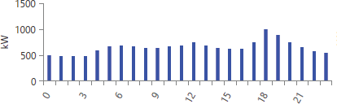
Figure 1. Daily load profile of the Itele community.
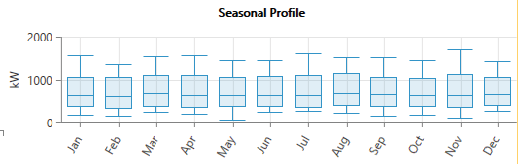
Figure 2. Seasonal load profile of the Itele community.
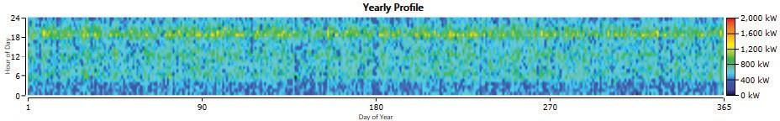
Figure 3. Yearly load profile of the Itele community.

Earth collects approximately 10,000 terawatts (TW) of sun radiation each day [5]. In stark con- trast, the total global energy consumption in 2015 was approximately 17.4 TW [6]. This comparison highlights the immense potential of solar energy: the solar radiation absorbed by the earth in just 1 hour exceeds the annual global consumption by a factor of two. Furthermore, with energy consump- tion projected to grow by nearly 56% by 2040 [7], harnessing solar energy could be crucial in meet- ing future energy demands sustainably. This vast, untapped resource offers a promising solution to the impending energy crisis, emphasizing the need for innovative approaches to efficiently capture and utilize solar power.

